Development of a Proficiency-Based Curriculum
to Teach and Assess Advanced Laparoscopic Skills

Principal Investigator:
Co-Principal Investigators:

Abstract
Objectives: Current simulation curricula for laparoscopic surgery do not reflect the complexity of the skills required in the operating room, especially for suturing. Low cost models have been developed to help residents acquire advanced suturing skills. The purpose of this study is to collect validity evidence for these training models and their metrics as measures of advanced suturing skill, and to establish proficiency-based benchmarks that can be used in an advanced curriculum.
Design: Multi-institutional collaborative study (cross-sectional and quasi-experimental study).
Setting: General surgery residency programs and Fellowship Council-accredited Fellowship programs in Canada and the United States.
Statistical analysis: Descriptive and inferential statistics including inter-rater reliability, internal consistency, comparisons between senior residents and MIS surgeons, and correlation between time/accuracy scores and performance assessments. The proficiency level for each task will be determined through performance of the surgeons in MIS/Bariatric services on each of the advanced suturing tasks using time and accuracy (penalty) metrics.
Conclusion: Validity evidence for the tasks and metrics could help to increase the quality and value of advanced laparoscopic suturing curricula that both teach and assess crucial skills of laparoscopic suturing. In addition, proficiency-based benchmarks support curricula development and motivate learners. An advanced laparoscopic suturing curriculum that includes these training models may improve residents’ laparoscopic suturing competency and better prepare residents for independent practice.

Backgrounds
Significant concerns in graduated residents
Laparoscopic surgery has evolved over the past 2 decades and advanced laparoscopic procedures have become routine practice among general surgeons. However, the majority of general surgery residents currently feel that they would not be comfortable performing advanced laparoscopic procedures at the end of residency training, and that the majority would pursue fellowship training to acquire these technical skills⁽¹⁻³⁾. A recent survey of the program directors in the Fellowship Council, consisting of non-ACGME accredited Minimally Invasive Surgery (MIS) fellowships in Canada and US, reported that 30% of program directors felt that graduated general surgery residents were not able to atraumatically manipulate tissue, and 60% of program directors thought that graduates were not proficient in laparoscopic suturing at the beginning of their MIS fellowships⁽⁴⁾.
Laparoscopic suturing as an essential advanced laparoscopic skill
Laparoscopic suturing is an essential technique required for a wide range of advanced laparoscopic procedures including closure of hiatal defects, peritoneal and mesenteric closure, and bowel anastomosis⁽⁵⁾. Laparoscopic suturing is also needed when dealing with intraoperative complications. This skill, however, is one of the most challenging for surgical trainees to master. Reasons for this include variability of suturing techniques, lack of advanced models and training curricula that reflect clinical complexities, and minimal trainee exposure to advanced MIS procedures during residency^{(6,7)}.
Need to teach and assess advance laparoscopic suturing skills
The Fundamentals of Laparoscopic Surgery (FLS) is a standardized program to develop and assess basic laparoscopic skills. Evidence supports the use of low-fidelity bench-top simulators to develop basic fundamental laparoscopic skills and transfer of these skills to the clinical environment has been repeatedly demonstrated⁽⁸⁻¹²⁾. However, there is a considerable gap between the complex skills required to perform safe laparoscopic suturing in the operating room (OR) and the more basic skills acquired and assessed with FLS⁽¹³⁾. Several advanced laparoscopic suturing tasks have been developed in the past including synthetic bowel models, virtual reality simulations with motion-based metrics, explanted porcine small intestine models placed in video trainers with motion-based metrics and performance assessment instruments, and live animal models^{(5, 14,15)}. These models have several limitations in terms of cost and lack of robust validity evidence to support them as measures of advanced laparoscopic suturing skills. The limitation of animal models is that they can be difficult to standardize and, in most instances, lack proficiency-based benchmarks. Models used for assessment require standardization and ideally, if also designed for training, should be inexpensive and flexible with regards to individual training needs. Therefore, there is a need to develop cost-effective laparoscopic suturing tasks that better reflect complexities in practice. Simulation-based training also provides an obvious platform for the sustained, deliberate practice required for the development of expertise.
Development of advanced laparoscopic suturing skills models (Appendix C)
From our qualitative needs assessment, we identified 3 important advanced laparoscopic suturing skills that are not effectively taught and assessed using current bench-top simulated modules. In response, we developed 3 inexpensive platforms and tasks using readily available materials: needle handling, suturing under tension, and continuous suturing (Appendix D). Nepomnayshy et al. also developed 3 additional advanced tasks based on FLS suturing tasks. They have demonstrated discriminative validity for a series of advanced laparoscopic suturing tasks to teach and assess more advanced laparoscopic skills⁽¹³⁾.
Proficiency-based training for motor skill acquisition
By defining expert-derived performance benchmarks, proficiency-based training has been demonstrated as an optimal approach for technical skills acquisition. Proficiency-based curricula help trainees achieve a pre-determined level of expertise, regardless of individual skill acquisition learning curves^{(16,17)}. Proficiency-based training could increase learner motivation and lead to improved performance when compared to training that does not clearly establish objectives^{(18, 19)}.
Objectives
The purpose of this multi-institutional collaborative study is to collect validity evidence for the advanced laparoscopic suturing tasks and their metrics as measures of these skills, and to establish expert-derived performance goals (proficiency-based benchmarks) that can be used in an advanced laparoscopic skills curriculum.
Methodology
Project design
The proposed project is a multi-institutional prospective study that will be conducted in two parts: (1) Establishment of proficiency-based benchmarks based on MIS surgeons’ performance at beta sites in Canada and the United States: Carolinas Health Care System, Lahey Hospital and Medical Center, LSU Health Sciences Center, McGill University Health DCntre, MedStar Georgetown University Hospital, University of Arizona, UT Southwestern Medical Center, Baystate Medical Center, and UT Galveston, Virginia Mason Medical Center, etc. (2) Development of a proficiency-based advance laparoscopic skills curriculum.
(1) Establishment of proficiency-based metrics
A total of at least 3 surgeons who regularly perform MIS or Bariatric surgery (≥25 cases/year that require laparoscopic suturing) from each institution will be recruited to perform 6 advanced laparoscopic suturing tasks placed in the FLS trainer box (VTI Medical, Waltham, MA). Each surgeon will perform the entire series of the tasks twice. All participants will be allowed to perform one of the FLS suturing tasks (either intra or extracorporeal knot) for up to 3 minutes (at least 1 minute) as a warm up prior to testing. They will view instructional videos before attempting each task. After completion of the tasks, participants will be given a questionnaire including demographics, clinical experience, and perceived educational value of the tasks. The proficiency benchmarks for each task will be determined through performance of the surgeons using time and accuracy (penalty) metrics.
(2) Baseline assessment of surgical trainees and investigation of feasibility of proficiency-based curriculum
A total of at least 3 FLS-certified general surgery senior residents (post-graduate years 3-5) and an MIS/Bariatric fellow from each institution will be recruited to perform the advanced laparoscopic suturing tasks. The testing protocol will be similar to part (1). After baseline assessments, the same surgical trainees will be enrolled in proficiency-based training. Over a 2-month period, the trainees will practice the tasks in a distributed fashion 1–2 hours per week. Each task will be practiced in order (Tasks 1–6) until the proficiency levels are achieved for all six tasks on at lease 2 consecutive repetitions. At post-testing, the participants will perform each task after their training.
Research instruments
Simulation training models for advanced laparoscopic suturing skills (Appendix C)
Based on survey results of fellows and program directors in the Fellowship Council programs, as well as discussion amongst subject-matter experts from the Society of American Gastrointestinal and Endoscopic Surgeons’ and the Association for Surgical Education’s advanced laparoscopic surgery project the following 6 tasks were chosen for this study: (1) needle handling (NH), (2) off-set forehand suturing (OF), (3) off-set backhand suturing (OB), (4) confined space suturing (CF), (5) suturing under tension (UT), and (6) continuous suturing (CS).
Metrics for advanced laparoscopic suturing models
We will use both time and accuracy to score participants. In addition, task-specific performance assessment tools will be used.

Time and accuracy (Appendix E)
The scoring consists of a combination of time taken to complete the tasks and accuracy. Accuracy will be scored using predefined penalties that will be mentioned in each of the task descriptions.
Task-specific performance assessment instruments (Appendix F)
From interviews of expert surgeons using recorded performances of each task, we generated task-specific instruments to help trainees improve their laparoscopic suturing skills by providing them with meaningful, focused formative feedback.. Performance was graded on a 3-point Likert scale (“does well”, “needs some improvement”, and “does poorly”) and scores will be calculated as a sum of those points. We will develop instruments for the remaining tasks (OF, OB, and CF) using the same methodology for further analyses.
Post-test questionnaire (Appendix G)
Participants will be administered an anonymous survey after completion of all tasks to obtain data on demographics and prior experience with laparoscopic suturing. Participants will be asked about their agreement with statements for each task using a Likert scale such as: usefulness of the task for assessing technical competence, and training value.
Data collection procedures
All participants will be assigned a candidate identification number. Each of their scores will be entered into a database using this identification. Investigators will collect the results in a password-protected database stored at the host site.
(1) At least 1 performance of each task will be timed by two raters at each institution, and predefined penalties will be scored by two raters at McGill University. All performance will be video recorded for further evaluations. A total of at least 5 random recorded performance of each task will be evaluated by two raters including surgeons in MIS/Bariatric service or trained raters who are blinded to identity and training/experience.
(2) The data collection will be similar to (1). In addition, the trainees will self-score each performance during training and record all time and accuracy scores on paper score sheets. Attendance and training time will be tracked using a sign-in log.
Data Analysis
Proficiency-based benchmarks
The proficiency level for each task will be determined through performance assessment of MIS/Bariatric surgeons on each task using time and accuracy (penalty) metrics. Mean performance times and penalties for all subjects will be used, and any data outside greater than 2 standard deviations from the mean will be excluded. The trimmed mean will then be used as the basis for determining the proficiency-based benchmarks.
Validity and Reliability
The current conceptual framework of validity will be used to assess evidence for validity of the tasks and metrics as measures of laparoscopic suturing skills⁽²⁰⁾. The inter-rater reliabilities of the tasks will be calculated using a two way random model of intraclass correlation coefficients (ICCs). Internal consistency will be estimated using Cronbach’s alpha. Inter-group comparisons for both time and accuracy scores and performance assessment scores will be made using Mann–Whitney U test. Time/accuracy scores and performance assessment scores of each task will be compared using Peason’s correlation coefficient. Both time/accuracy and performance assessment scores of each task, and self-reported experience will be compared using Spearman's rank correlation coefficient. All analyses will be performed using SPSS version 21 (IBM, Armonk, NY) or JMP version 11 (SAS Institute Inc, Cary, NC).
Power analysis and sample size
Pilot performance data of the NH, UT, and CS tasks from 18 senior surgical residents and 13 surgeons at the host site showed significant differences in performance in both training platforms (Appendix D). In order to show a similar difference between the two groups in performance with an α of 0.05 and a power of 80%, with 2-sided testing, a total of at least 28 participants per group will be required in the NH task, UT 12/group, and CS 8/group. We will aim to recruit a total of at least 30 subjects in both surgeon and surgical trainee group. With an ICC of 0.95 and a confidence interval of 0.10, a total of 10 performances will be needed for both time/accuracy scoring and performance assessment instruments.
Significance to postgraduate medical education
This study was designed based on a quantitative and qualitative needs assessment. The data can provide validity evidence for the metrics of novel advanced laparoscopic suturing tasks as measures of laparoscopic suturing skills. Validity evidence for these tasks and metrics could help develop an advanced laparoscopic suturing curriculum that would be used to teach and assess important skills of laparoscopic suturing required in practice, which are currently not taught and assessed by the FLS program. In addition, proficiency-based benchmarks support curricula development and learner motivation. Finally, advanced laparoscopic suturing curricula can improve residents’ laparoscopic suturing skills, and better prepare them for independent practice while optimizing patient safety.
Proposed project schedule (Appendix A)
A timeline for project completion is depicted in Appendix A. All components of our study are currently at an operational state. This includes task development, questionnaire, performance assessment instruments, and recording equipment at each site.
Anticipated ethical issues
Approval from the IRB of the Faculty of Medicine at McGill University has been obtained for development of advanced laparoscopic skills models and metrics. After defining expert-derived performance goals, approval for the final part of implementing the proficiency-based curriculum will be submitted. The evaluation of residents will not change the way of residency training progress or the quality of the care patients receive. The data gathered will be coded and all reporting will be confidential and will not impact the residents’ official evaluations. Participants can chose to withdraw at any point during the study and they will be made explicitly aware of this at the time of informed consent. IRB approval will need to be obtained at all of the beta sites prior to commencement of the experiments.
Anticipated outcomes
The pilot studies (AppendixD) suggested that a series of the new training models and their metrics have discriminative ability to assess advanced laparoscopic skills⁽¹³⁾. In addition, our pilot data support the validity of the metrics used to assess these skills, including excellent inter-rater reliability and internal consistency, and a strong correlation between time and accuracy scores with the performance assessment scores. We anticipate similar results from this multi-institutional collaborative study to support the generalizability of these findings.
Plan to disseminate research findings
The findings of this series of experiments will be submitted to both national and international peer-reviewed meetings of different professional societies such as the Association for Surgical Education (ASE), and the Society of American Gastrointestinal and Endoscopic Surgeons (SAGES. The findings will also be submitted for publication to an appropriate peer- reviewed journal. The findings could foster the integration of proficiency-based advanced laparoscopic skills curriculum into residency programs and Fellowship Council-accredited programs collaborating with the Association for Surgical Education (ASE) and the Society of American Gastrointestinal and Endoscopic Surgeons (SAGES).
Bibliography
1. Borman KR, Vick LR, Biester TW, Mitchell ME. Changing Demographics of Residents Choosing Fellowships: Longterm Data from The American Board of Surgery. J Am Coll Surg. Elsevier; 2008 May;206(5):782–8.
2. Qureshi A, Vergis A, Jimenez C, et al. MIS training in Canada: a national survey of general surgery residents. Surg Endosc. 2011 Sep;25(9):3057–65.
3. Park A, Kavic SM, Lee TH, Heniford BT. Minimally invasive surgery: the evolution of fellowship. Surgery. 2007 Oct;142(4):505–13.
4. Mattar SG, Alseidi AA, Jones DB, et al. General Surgery Residency Inadequately Prepares Trainees for Fellowship: Results of a Survey of Fellowship Program Directors. Ann Surg. 2013 Sep;258(3):440–9.
5. Dehabadi M, Fernando B, Berlingieri P. The use of simulation in the acquisition of laparoscopic suturing skills. Int J Surg. 2014;12(4):258–68.
6. Palter VN, Orzech N, Aggarwal R, et al. Resident perceptions of advanced laparoscopic skills training. Surg Endosc. 2010 Nov;24(11):2830–4.
7. Rattner DW, Apelgren KN, Eubanks WS. The need for training opportunities in advanced laparoscopic surgery. Surg Endosc. 2001 Oct;15(10):1066–70.
8. Derossis AM, Fried GM, Abrahamowicz M, et al. Development of a model for training and evaluation of laparoscopic skills. Am J Surg. 1998 Jun;175(6):482–7.
9. Fried GM, Feldman LS, Vassiliou MC, et al. Proving the value of simulation in laparoscopic surgery. Ann Surg. 2004 Sep;240(3):518–25–discussion525–8.
10. McCluney AL, Vassiliou MC, Kaneva PA, et al. FLS simulator performance predicts intraoperative laparoscopic skill. Surg Endosc. 2007 Nov;21(11):1991–5.
11. Sroka G, Feldman LS, Vassiliou MC, et al. Fundamentals of laparoscopic surgery simulator training to proficiency improves laparoscopic performance in the operating room-a randomized controlled trial. Am J Surg. 2010 Jan;199(1):115–20.
12. Korndorffer JR, Dunne JB, Sierra R, et al. Simulator training for laparoscopic suturing using performance goals translates to the operating room. ACS. 2005 Jul;201(1):23–9.
13. Nepomnayshy D, Whitledge J, Birkett R, et al. Evaluation of advanced laparoscopic skills tasks for validity evidence. Surg Endosc. Springer US; 2014 Jul 9:1–6.
14. Moorthy K, Munz Y, Dosis A, et al. Bimodal assessment of laparoscopic suturing skills: construct and concurrent validity. Surg Endosc. 2004 Nov;18(11):1608–12.
15. Aggarwal R, Boza C, Hance J, et al. Skills acquisition for laparoscopic gastric bypass in the training laboratory: an innovative approach. Obes Surg. 2007 Jan;17(1):19–27.
16. Scott DJ, Ritter EM, Tesfay ST, et al. Certification pass rate of 100% for fundamentals of laparoscopic surgery skills after proficiency-based training. Surg Endosc. 2008 Aug;22(8):1887–93.
17. Kolozsvari NO, Feldman LS, Vassiliou MC, et al. Sim one, do one, teach one: considerations in designing training curricula for surgical simulation. J Surg Educ. 2011 Sep;68(5):421–7.
18. Stefanidis D, Acker CE, Greene FL. Performance Goals on Simulators Boost Resident Motivation and Skills Laboratory Attendance. JSURG. 2010;67(2):66–70.
19. Madan AK, Harper JL, Taddeucci RJ, Tichansky DS. Goal-directed laparoscopic training leads to better laparoscopic skill acquisition. Surgery. 2008 Aug;144(2):345–50.
20. Joint American Educational Research Association. Standard for Educational and Psychological Testing. Washington, DC: American Educational Research Association; 1999. 1-211.
Appendices
- Figure 1. Proposed project schedule
- Figure 2. Advanced laparoscopic suturing tasks (Figure 2.1-2.6)
- Pilot data of advanced laparoscopic training models (Table 1)
- Research Instruments, time and accuracy scoring template
- Research Instruments, performance assessment instruments
- Research Instruments, post -test questionnaire

Appendix A

Figure 1. Schedule of activities for the proposed study
Activities | Months (Start July 2015 – June 2017)
 | 1 | 2 | 3 | 4 | 5 | 6 | 7 | 8 | 9 | 10 | 11 | 12 | 13 |  | 14 |  | 15 |  | 16 |  | 17 |  | 18 |  | 19 |  | 20 |  | 21 |  | 22 |  | 23 |  | 24
(1) Establishment of proficiency-based benchmarks
Recruitment and data collection
Data analysis (time/accuracy scores and questionnaire data)
Development of performance assessment instruments (interviews and data analysis)
Assessment of recorded performance
Presentation of findings to professional societies
(2) Baseline assessment of surgical trainees and investigation of feasibility of proficiency-based curriculum
Recruitment and data collection
Evaluation of recorded performance
Data analysis (time/accuracy scores, performance assessment scores, and questionnaire data)
Presentation of findings to professional societies
Submission for Manuscripts

Appendix B

Figure 2. Advanced laparoscopic suturing tasks
Figure 2. 1 Needle Handling task  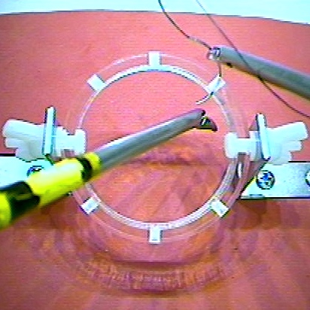 | 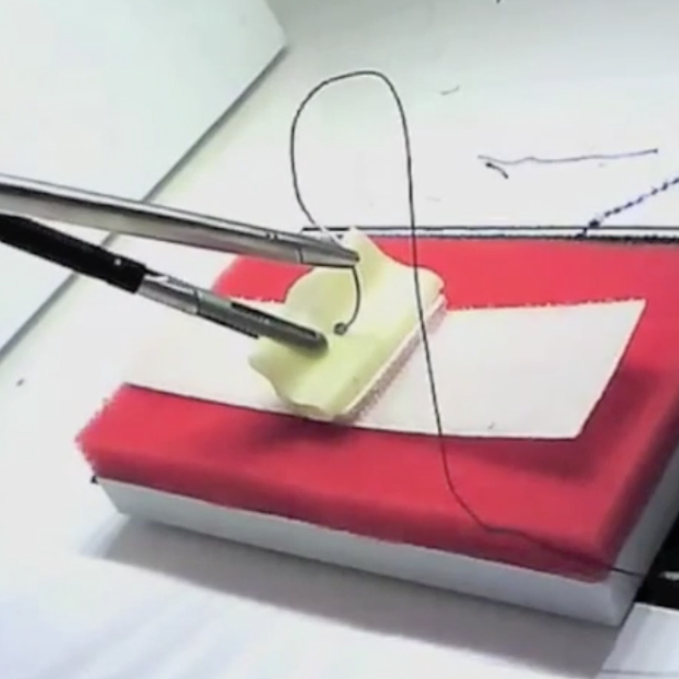  Figure 2. 2 Off-set Forehand Suturing task
Figure 2. 3 Off-set Backhand Suturing task  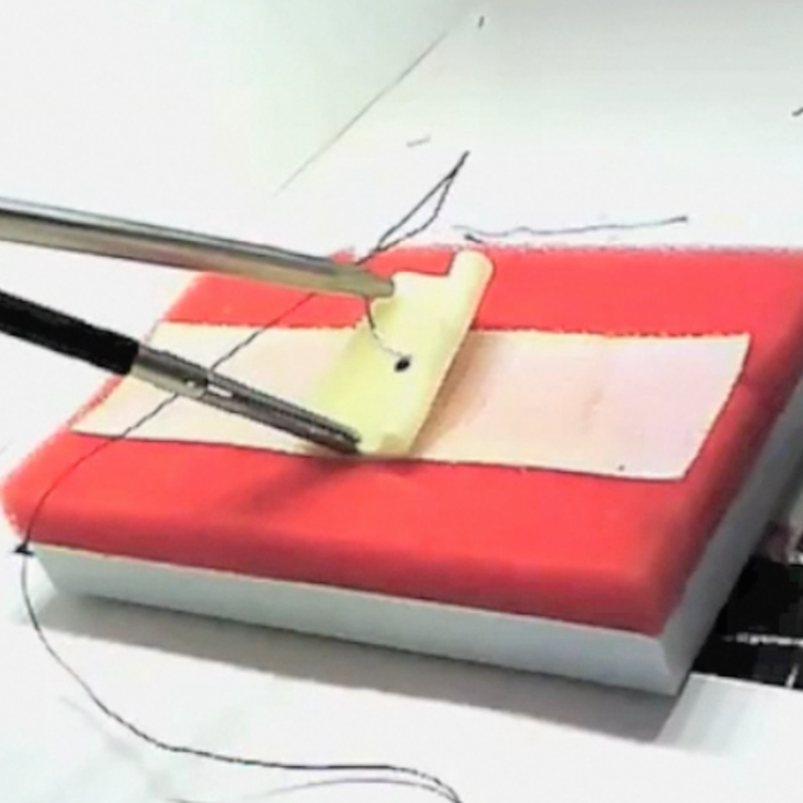 | Figure 2. 4 Confined Space Suturing task  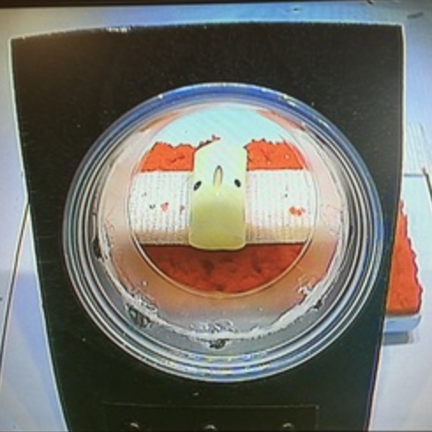
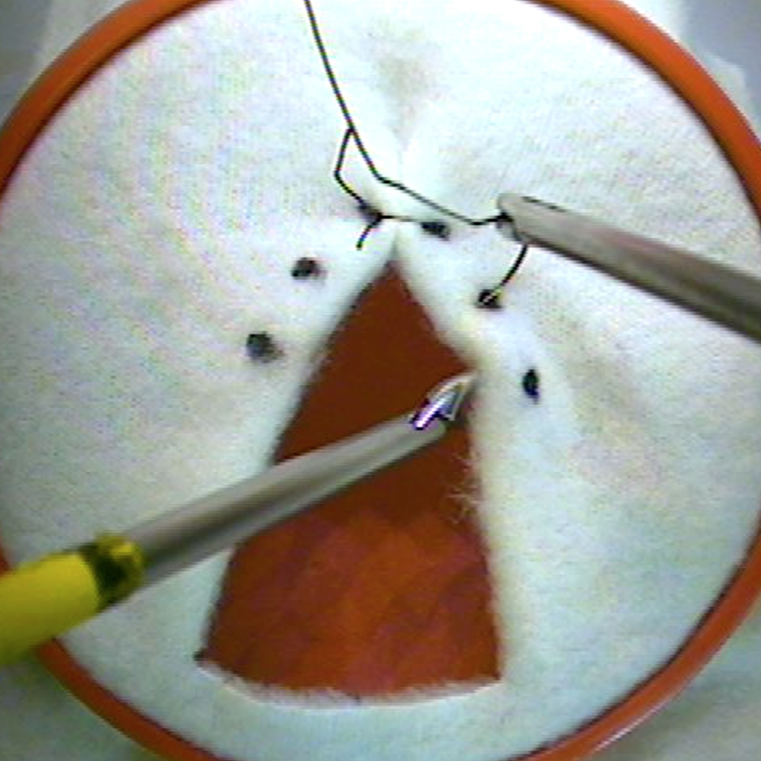  Figure 2. 5 Suturing Under Tension task | Figure 2. 6 Continuous Suturing task  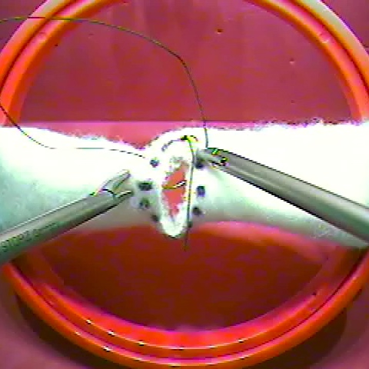

1. Needle Handling task
The aim of this task is to manipulate the needle at desired angles and directions. A 5 cm diameter circular acrylic platform with six standardized holes oriented at different angles will be used for testing. Although the angle of the circular platform can be tailored to individual needs, it will be fixed at a 25° angle for this study. Participants will be asked to pass the needle of a 15cm 2-0 Silk suture through 6 holes from outside to inside in a sequential, counter-clockwise fashion starting from the top right hole. Timing will start when any instrument is seen on the monitor and end when the needle and entire suture is removed from the last hole. The suture will not have to be removed completely from the holes except for the last hole. This task will be scored by time of completion with a cutoff time of 300 seconds, and a penalty score will be assigned based on the number of times the needle is dropped outside the field of view.
2-3. Off-set Forehand/Backhand Suturing task
The aim of this task is to acquire both forehand and backhand suturing skills in the off-set camera position. Participants’ first throw must be a Surgeon’s knot or double throw, followed by two single throws. They will be provided with one 15 cm 2-0 Silk sutures. The timing will start when any instrument is seen on the monitor and end when the suture is cut. Scoring involved timing of completion (cutoff time 600 seconds), and a penalty score reflecting accuracy. The penalty score will account for gaps between in the closure, the distance from the premarked dots and where the sutures is placed, and the security of the knots.

4. Confined Space Suturing task
The aim of this task is to acquire suturing skills in the confined space and off-set camera position. Participants’ first throw must be a Surgeon’s knot or double throw, followed by two single throws. They will be provided with one 15 cm 2-0 Silk sutures. The timing will start when any instrument is seen on the monitor and end when the suture is cut. The metrics and cutoff time will be similar to the Off-set Forehand/Backhand suturing task.

5. Suturing Under Tension task
The aim of this task is to approximate tissues under tension, such as what would be required for hiatal hernia surgery or Nissen fundoplication. This task incorporates a fleece fabric with a standardized triangular gap and 6 pre-marked dots. The fabric will be fixed using a 10 cm embroidery ring that was hung from the platform with limited stabilization. Three dots will be marked 1 cm apart on both sides of the gap from the apex. Participants will be instructed to close the gap using 3 interrupted sutures. They will be provided with three 75 cm 2-0 Silk sutures. They will be free to decide on the suture length and whether or not to perform intracorporeal or extracorporeal ties. While at least 3 ties for each suture will be required, there will be no rules regarding the knot type. The timing will start when any instrument is seen on the monitor and end when the final suture is cut. Scoring will involve timing of completion (cutoff time 900 seconds), and a penalty score reflecting accuracy. The penalty score will account for gaps between in the closure, the distance from the premarked dots and where the sutures were placed, and the security of the knots.
6. Continuous Suturing task
The aim of this task is to acquire continuous closure skills, such as what would be required for peritoneal or mesenteric closure or bowel anastomosis. This task consists of a fleece fabric-made simulated intestine (14cm x 3.5cm) with a finger-sized circular defect and 12 pre-marked dots, fixed on a 10 cm embroidery ring hung from the platform with limited stability. Participants will be asked to close the defect using a continuous suturing technique. They will be provided with two 75 cm 2-0 Silk sutures and could use more than 1 suture if desired. They will be allowed to decide on the suture length and whether or not to perform intracorporeal or extracorporeal ties. While at least 3 ties for each knot will be required, there will be no rule regarding the knot type. The timing will start when any instrument is seen on the monitor and end when the suture is cut after closure of the defect. The metrics will be similar to the UT task, except for the cutoff time, which is 1200 seconds. Accuracy will be also assessed based on the number of skipped dots.

Appendix C
Development of advanced suturing models needs assessment
Qualitative investigations including semi-structured interviews of general surgery residents at McGill University and MIS surgeons in Canada and the United States, observations of MIS cases that required suturing, analysis of surgical videos in order to develop the advanced tasks for laparoscopic suturing. From this, we identified 3 important skills required to master laparoscopic suturing that are not effectively taught and assessed using current bench-top models. Based on these gaps, 3 platforms were developed using readily available materials: needle handling (NH), suturing under tension (UT), and continuous suturing (CS). The estimated cost of these multiuse platforms was about CAD$10 each and consumables of UT and CS tasks (a piece of fabric) were about CAD$ 0.25. To acknowledge diversity in experience levels, techniques to be used, and the limits of cognitive capacity, strictly standardized techniques were not specified.

Pilot validity evidence for advanced laparoscopic suturing models
Time and accuracy scoring
Our pilot data support the validity of the metrics used to assess advanced laparoscopic suturing skills (NH, UT, CS). The inter-rater reliabilities for all tasks were 0.99 (95% CI, 0.99–1.00) and internal consistency was 0.80. MIS surgeons had significantly greater scores in each of the new tasks compared to senior residents (Table 2). As level of training increased, median scores increased significantly, and the variance in performance decreased for all tasks. While all MIS surgeons completed the 3 tasks within the allotted time, a total of 6 (33%) residents could not complete at least one out of the 3 tasks. The scores of all tasks correlated positively with self-reported laparoscopic suturing experience: NH 0.51, UT 0.70, and CS 0.65, p<0.01 (Fig. 3). Additionally, Among the 31 participants, the majority of participants agreed or strongly agreed that the tasks was relevant to clinical practice (NH 86%, UT 100%, CS 100%); the tasks helped to improve technical competence (NH 93%, UT 100%, CS: 100%); and the tasks adequately measured technical competence of laparoscopic suturing (NH: 89%, UT: 100%, CS: 100%).

Table 1. Scores of the Needle handling, Suturing under tension, and Continuous suturing tasks according to the level of training (n = 31). Results are presented as median [25th; 75th percentile].
 | Senior Residents  n=18 | MIS surgeons  n=13 | p value
Needle handling | 349 [258; 434] | 404 [353; 474] | 0.04
Suturing under tension | 246 [109; 440] | 535 [369; 627] | <0.01
Continuous suturing | 282 [83; 507] | 820 [669; 886] | <0.01
MIS, minimally invasive surgery

Performance assessment instruments
The recorded performance of residents and MIS surgeons on all of the tasks; in total 27, 23, and 27 videos were assessed by two blinded raters for NH, UT, and CS respectively. ICCs for NH, UT, and CS were 0.90 (95%CI: 0.79-0.95), 0.87 (0.73-0.95) and 0.90 (0.76-0.95). Scores were found to correlate strongly with combined time and accuracy scores for UT (0.82, p<0.01) and CS (0.81, p<0.01), and moderately for NH (0.65, p<0.01). MIS surgeons also performed significantly better than senior residents on UT (experts: 29.5[26.5-33] vs. novices: 23.75 [19.6-29.1], p=0.02) and CS (experts: 34.5[30-36.5] vs. novices 26[21.4-29], p<0.01).

Appendix D

CODE: ____________________
 |  | Rater 1 |  | Rater 2
1. Needle Handling (cutoff = 300 sec)
Time (second)
Penalty
 | Total of needle outside of the view (number: e.g., 0, 1...)
2. Off-set Forehand Suturing task (cutoff = 600 sec)
Time (second)
Penalty
 | Gaps between in the closure (mm)
 | The distance from the premarked dots and where the sutures were placed (mm)
 | The security of the knots*
3. Off-set Backhand Suturing task (cutoff = 600 sec)
Time (second)
Penalty
 | Gaps between in the closure (mm)
 | The distance from the premarked dots and where the sutures were placed (mm)
 | The security of the knots*
4. Confined Space Suturing task (cutoff = 600 sec)
Time (second)
Penalty
 | Gaps between in the closure (mm)
 | The distance from the premarked dots and where the sutures were placed (mm)
 | The security of the knots*
5. Suturing Under Tension task (cutoff = 900 sec)
Time (second)
Penalty
 | Gaps between in the closure (mm)
 | The distance from the premarked dots and where the sutures were placed (mm)
 | The security of the knots*
6. Continuous Suturing task (cutoff = 1200 sec)
Time (second)
Penalty
 | Gaps between in the closure (mm)
 | The distance from the premarked dots and where the sutures were placed (mm)
 | The security of the knots*
 | The number of skipped dots
* The security of the knots: secure knot = 0, Slipping knot = 10, Knot comes apart = 20

Appendix E

The Needle Handling task:  How well does the resident perform the following skills? | CC | Does poorly  (0) | Needs some improvement  (1) | Does well (2)
Anticipates what angle is required to penetrate the target tissue | 7
Loads the needle at the desired angle | 6
Interprets the needle angle correctly when loading it on the needle driver | 1
Coordinates the use of both hands to manipulate the needle | 3
Enters the tissue perpendicularly with the needle | 5
Keeps the target tissue steady while performing the task | 5
Follows the curve of the needle when passing it through the tissue | 5
Moves the instruments smoothly towards specific targets | 6
Works with the instruments at an appropriate depth (i.e. not too close to the camera) | 1
Keeps the instruments within the field of view | 2
COMPREHENSION CATEGORY (CC) KEY: 1 Depth Perception, 2 Laparoscopic Safety, 3 Bimanual Dexterity, 4 Exposure, 5 Tissue Handling, 6 Instrument Manipulation, 7 Planning

The Suturing Under Tension task:  How well does the resident perform the following skills? | CC | Does poorly  (0) | Needs some improvement  (1) | Does well (2)
Selects an appropriate suture length for the task | 7
Anticipates what angle is required to penetrate the target tissue | 7
Loads the needle at the desired angle | 6
Interprets the needle angle correctly when loading it on the needle driver | 1
Coordinates the use of both hands to manipulate the needle | 3
Keeps the target tissue steady while suturing | 5
Enters the tissue perpendicularly with the needle | 5
Follows the curve of the needle when passing it through the tissue | 5
Changes the angle of the tissues to optimize the view | 4
Takes the tissue in 2 separate bites if needed based on the size of the gap between the tissues | 5
Leaves suture tail an appropriate length when tying the knot | 7
Understands the relationship between the suture and the needle driver to tie a knot | 6
Uses an appropriate knot type (surgeon's knot slip knot, etc.) to approximate the tissues | 2
Ties the knots securely (tightly) | 2
Works with the instruments at an appropriate depth (i.e. not too close to the camera) | 1
Keeps the instruments within the field of view | 2
Moves the instruments smoothly towards specific targets | 6
Maintains awareness of the location of the needle tip throughout the task | 2&6
COMPREHENSION CATEGORY (CC) KEY: 1 Depth Perception, 2 Laparoscopic Safety, 3 Bimanual Dexterity, 4 Exposure, 5 Tissue Handling, 6 Instrument Manipulation, 7 Planning

The Continuous suturing task:  How well does the resident perform the following skills? | CC | Does poorly  (0) | Needs some improvement  (1) | Does well (2)
Chooses the correct orientation to close the enterotomy (transverse) | 7
Selects an appropriate suture length for the task | 7
Anticipates what angle is required to penetrate the target tissue | 7
Loads the needle at the desired angle | 6
Interprets the needle angle correctly when loading it on the needle driver | 1
Coordinates the use of both hands to manipulate the needle | 3
Keeps the target tissue steady while suturing | 5
Enters the tissue perpendicularly with the needle | 5
Follows the curve of the needle when passing it through the tissue | 5
Changes the angle of the tissues to optimize the view | 4
Takes the tissue in 2 separate bites if needed based on the size of the gap between the tissues | 5
Tightens the suture line and maintains appropriate tension while running the suture | 2&7
Leaves suture tail an appropriate length when tying the knot | 7
Understands the relationship between the suture and the needle driver to tie a knot | 6
Uses an appropriate knot type (surgeon's knot slip knot, etc.) to approximate the tissues | 2
Ties the knots securely (tightly) | 2
Works with the instruments at an appropriate depth (i.e. not too close to the camera) | 1
Keeps the instruments within the field of view | 2
Moves the instruments smoothly towards specific targets | 6
Maintains awareness of the location of the needle tip throughout the task | 2&6
COMPREHENSION CATEGORY (CC) KEY: 1 Depth Perception, 2 Laparoscopic Safety, 3 Bimanual Dexterity, 4 Exposure, 5 Tissue Handling, 6 Instrument Manipulation, 7 Planning

Appendix G

CODE: _____________ Date: DD / MM / YY

1. Gender:
 | Male |  | Female

2. Age: ____________

3. Institution:

 | Baystate Medical Cneter |  | MedStar Georgetown University
 | Carolinas HealthCare System |  | Virginia Mason Medical Center
 | Lahey Medical Center |  | University of Arizona
 | LSU Health |  | UT Southwestern
 | McGill University |  | UT Galverston

4. Have you completed a fellowship training in Minimally Invasive Surgery?

Yes
No

5. Year(s) in practice after fellowship or residency : ____________

6. Type of MIS procedures (percentage of your Practice, total=100%):
Upper Forgut |  | Solid Organ
Bariatric |  | HPB(excluding cholecystectomy)
Colorectal |  | Thoracic
Abdominal Wall |  | Other MIS

7. Laparoscopic suturing experience (annual case in the OR)
 | None | 1-25 | 26-50 | 51-100 | 101+
Intracorporeal suturing without an assist device (e.g. Endo Stitch)
Extracorporeal Suturing without an assist device (e.g. Endo Stitch)
Suturing with an assist device (e.g. Endo Stitch)

8. Please answer the following questions about the Needle Handing task.

1. The Needle Handling task presents a technical challenging for surgical trainees who have a FLS certification.
 | Strongly Disagree |  |  |  |  |  | Strongly Agree

2. The Needle Handling task reflects clinical practice.
 | Strongly Disagree |  |  |  |  |  | Strongly Agree

3. The Needle Handling task serves to improve performance of laparoscopic suturing in the OR.
 | Strongly Disagree |  |  |  |  |  | Strongly Agree

4. The Needle Handling task can be used to assess competence.
 | Strongly Disagree |  |  |  |  |  | Strongly Agree

5. The Needle Handling task should include the Expert Laparoscopic Skills curriculum.
 | Strongly Disagree |  |  |  |  |  | Strongly Agree

Please include any comments or feedback about the Needle Handling task.

9-13. The questions of each task will be similar to the Needle Handling task.

